LOVE MACHINE
a photo series by Claudia Starkey

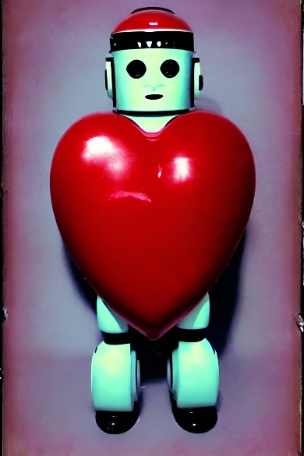
Love Machine, a photographic series created using the first generation of artificial intelligence, presents a captivating and insightful glimpse into the early days of AI's attempt to mimic human creativity. With the advancement of AI technology, the algorithms have evolved to create more sophisticated and elaborate models. The photos in this series, however, showcase the humble beginnings of AI's creative journey. In a sense, they are a piece of history, documenting the early steps of AI in our world.
The artist behind the Love Machine series, Claudia Starkey, is a visionary who is fascinated by neurological diversity and how individual brains interpret input from the outside world. Her work explores how information is stored and processed, and how these processes influence our view of the world and our self-expression. Starkey's interest in neural pathways led her to explore the question of what love and companionship might look like to a robotic intelligence.
The resulting series of retro female robots, an insightful exploration of the relationship between AI and human emotions. The robots in the photos are presented with stereotypical characteristics of female forms, which is a nod to Starkey's experience of being raised in the Eastern Block and experiencing a predominant chauvinist landscape in her young years, but also not foreign to current settings of sexism and unequal gender exploitation through the latest technological innovations.
As we witness the rapid expansion of AI capabilities, there has been little attempt at documenting AI's first steps into our world. The Love Machine series is a valuable contribution to this field, capturing a moment in history when AI was still in its infancy. As the inexorable march of time unfolds, the evolution of AI technology continues to push the boundaries of what was once considered unimaginable. It is both awe-inspiring and humbling to contemplate the boundless potential for future innovation that this rapid progression portends, and to consider the myriad of mind-bending creations that may emerge from this ever-advancing frontier of human ingenuity. But for now, Love Machine reminds us of the humble beginnings of this revolutionary technology is full of potential and unease to the future of our world.
The Love Machine series represents a compelling and thought-provoking exploration into the depths of artificial intelligence and its capacity to conceive and engage with the complexities of love and intimate relationships. While AI technology has indeed achieved significant strides in emulating human behavior and emotions, the extent to which it can truly comprehend, and experience love remains a subject of ongoing debate and speculation within the scientific and philosophical communities.
The striking portrayal of robots is seemingly endowed with the capacity to express the nuances of love and desire. Nonetheless, the notion that these machines are genuinely experiencing these complex emotions is open to debate. Although these robots may possess the capability to simulate emotional responses to specific stimuli, the argument can be made that they lack the multi-dimensional depth and profound emotional complexity that defines human beings.
On the other hand, some proponents of AI argue that as technology advances, AI will eventually be capable of experiencing emotions such as love. They argue that as AI becomes more advanced and sophisticated, it may develop consciousness and self-awareness, which would allow it to experience emotions and form relationships.
One reason why it is unlikely that AI will ever be able to feel human emotions as a pure neural network is that human emotions are not solely determined by neural activity. The biochemistry of love, for example, plays a crucial role in the experience of human emotions. The release of neurotransmitters such as dopamine, oxytocin, and serotonin, among others, contributes to the experience of emotions such as love, happiness, and pleasure.
Furthermore, human emotions are shaped by a variety of factors, including genetics, upbringing, culture, and life experiences. AI lacks the complexity and diversity of these factors, which limits its ability to understand and experience human emotions.
Another key factor is the subjective nature of emotions. Emotions are not objective, quantifiable phenomena but rather subjective experiences that are shaped by personal perceptions, beliefs, and values. It is therefore unlikely that AI, lacking a subjective self, will be able to fully understand or experience human emotions in the same way as humans.
The series represents a playful exploration of the broad themes of human love and sexuality. However, it also touches upon a timely and critical issue, namely the emerging discussion around the role of robots as companions and even romantic partners in the not-so-distant future. Such developments pose significant ethical questions and concerns about the nature of human-robot interactions and the potential implications for society as a whole. Therefore, this photographic series serves as an engaging and thought-provoking contribution to this ongoing discourse.
Regardless of whether AI is capable of experiencing genuine emotions, the series raises important questions about the nature of love and the role that technology plays in our understanding of it. It challenges us to think about the ways in which our perceptions of love and companionship are shaped by our interactions with technology and to consider the ethical implications of creating machines that can mimic human emotions and behaviors.
In conclusion, while AI may be able to simulate certain aspects of human emotions, it is unlikely that it will ever be able to feel human emotions as a pure neural network because it is lacking the biochemical and physiological processes that contribute to the experience of emotions. The subjective nature of feelings and the complex interplay of biological and environmental factors also make it unlikely that AI will be able to fully understand or experience human emotions in the same way as humans.

www.claudiastarkey.com

